C:\Users\Donavon Current\Documents\Harvard\HUIT\HUIT_LONG.eps

**eduroam**

User Guide

January 7, 2013

Prepared by: DC Current, Mark I. Mayes

**Table of Contents**

[1 Scope and Background 3](#_Toc331165015)

[1.1 Scope 3](#_Toc331165016)

[1.2 What is eduroam? 3](#_Toc331165017)

[1.3 Background 3](#_Toc331165018)

[1.3.1 Harvard Guest 4](#_Toc331165019)

[1.3.2 Harvard Help 4](#_Toc331165020)

[1.3.3 Harvard Secure 4](#_Toc331165021)

[1.3.4 eduroam 4](#_Toc331165022)

[1.3.5 Harvard University 4](#_Toc331165023)

[1.4 How does one get eduroam credentials? 5](#_Toc331165024)

# Scope and Background

## Scope

This document is relevant to the implementation of eduroam for use on the Harvard University wireless network, and globally at other educational institutions who are part of the global eduroam system.

## What is eduroam?

eduroam (**edu**cation **roam**ing) is the secure worldwide federated network access service developed for the international research and education community.

**For the traveler**: eduroam provides per-user, per-session encrypted network access for visitors from participating institutions, without the need to gain guest credentials on arrival to an eduroam enabled location. The connectivity is instantaneous and the infrastructure is authenticated by the user. Study abroad students can join thousands of eduroam hotspots without any hassle or any data roaming charges.

**For the institution**: eduroam removes the administrative steps required to provision visitors from other educational institutions. Access between networks from R&E institutions is negotiated once during the federation process and for all members of participating institutions. The eduroam network addresses CALEA requirements for visitors from other schools.

## Background

Harvard University Information Technology (HUIT) Network Services (NS) has been working toward a common, user-friendly wireless experience across the Cambridge campus areas formerly served by the Faculty of Arts Sciences (FAS) and University Information Services (UIS) Central Administration IT (CAIT) networks. Under the current Phase of the project, five wireless networks (SSIDs) are being extended throughout the campus. These include:

* Harvard Guest
* Harvard Help
* Harvard Secure
* eduroam
* Harvard University

### Harvard Guest

The Harvard Guest SSID is an open network without managed security measures, and is rate limited to 512kbps. This is approximately six times faster than a dialup modem, and is suitable for such internet usage as email and light web browsing.

### Harvard Help

In addition to providing access to the SecureW2 supplicant, Harvard Help provides a landing page with information on the five (5) SSIDs and contact information for each school’s support staff.

### Harvard Secure

Harvard Secure is a secure, encrypted wireless network that is the preferred wireless environment to be used for all University work. It requires use of client software called the SecureW2 supplicant. Once installed, this client saves your credentials and allows you to access the Harvard Secure network wherever it is available without your having to log in or take any action. Because it is encrypted, there is an additional layer of protection for all the data exchanged with your machine over this network.

Once the supplicant is installed, Harvard Secure is easy to use and is the recommended network for all University work over wireless.

If you wish to take advantage of the higher security provided by the *Harvard Secure* SSID, refer to the appropriate document for your client device or contact the Service Desk at [ithelp@harvard.edu](mailto:ithelp@harvard.edu) .

### eduroam

eduroam is a secure, encrypted wireless network that is provided for visiting faculty and students who have registered their equipment at their home institution. When a visiting user requests access to the eduroam SSID at Harvard with their appropriate login username@institution\_domain, the eduroam system will proxy their credentials to their home institution for authentication, and, if acceptable, will provide immediate access to Harvard’s wireless environment without further registration.

### Harvard University

The *Harvard University* SSID has been in use in the two areas and consolidation of these two separate networks is anticipated under a future phase of this project. Graphically, this is represented by the following diagram:

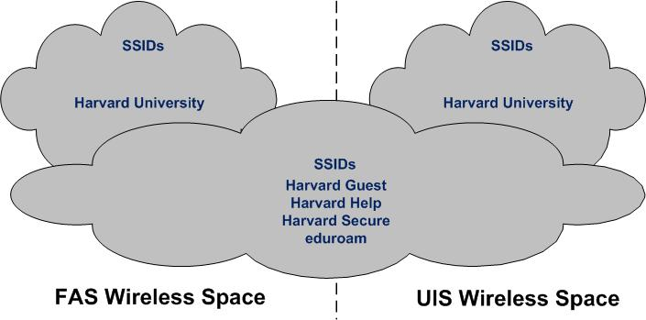

The user’s experience with an unregistered device associating with the *Harvard University* SSID differs dependent upon the access point (AP) that is in range and selected by the user’s device at the time the device attempts to associate with a wireless network. Please see the appropriate document for registering your device.

## What is my eduroam credential?

For Harvard faculty, staff, and students who plan on visiting another institution which has implemented eduroam, devices will need to implement a supplicant to store their appropriate credentials on a certificate within the device. The process is similar to that used to implement Harvard Secure.

The first step is to go to Harvard Help. This will explain the process to join the Harvard wireless environment. One of the choices will be eduroam. Clicking on eduroam will bring up an XpressConnect Wizard.

The XpressConnect Wizard guides the user through the 802.1x configuration process. It implements various security controls such as the Secure Socket Layer (SSL, a protocol for encrypting information over the Internet) common name and issuer verification. It installs necessary patches or Service Packs for older operating systems, such as XP Service Pack 2, and for Windows systems it installs the necessary SecureW2 supplicant.

The pictures below indicate the entries for the eduroam configuration process that will allow use of eduroam networks at other institutions.

C:\Users\Donavon Current\Documents\Harvard\eduroam\eduroam_start.tiff

This image shows the selection for Harvard Secure or eduroam. The process is similar for each, but slightly different in the Harvard ID. Harvard Secure configuration only requires the HUID, whereas eduroam configuration requires [[HUID]@harvard.edu](mailto:HUID@harvard.edu) so that the institution is included in the login name. This enables the other institution to request confirmation of credentials from Harvard.

C:\Users\Donavon Current\Documents\Harvard\eduroam\eduroam_creds.tiff

This image shows the suggested format of the login for eduroam which includes the harvard.edu suffix to the HUID.

C:\Users\Donavon Current\Documents\Harvard\eduroam\eduroam_creds_filled.tiff

This image shows the complete input including the PIN for the HUID.

Once configured, users can seamlessly access the “eduroam” SSID at any participating institution around the world. There should be no user action after the initial (XpressConnect) configuration. Users will simply need to log in to the “eduroam” SSID with [HUID]@harvard.edu.